


Data Compliance Test (DCT)
Test Cases for
Procedure Record

<HCP Name>

Table of Contents
1 Testing Instructions to HCPs 3
1.1 Self-Service Testing Phase 3
1.2 Final Testing Phase 3
1.3 Preparation of DCT Test Report 4
2 Test Case Details 5
PX-LV3-001 [FOR LEVEL 3 DATA UPLOAD ONLY] 5
PX-LV3-002 [FOR LEVEL 3 DATA UPLOAD ONLY] 9
PX-LV2-001 [FOR LEVEL 2 DATA UPLOAD ONLY] 12
PX-LV2-002 [FOR LEVEL 2 DATA UPLOAD ONLY] 14
3 Appendix – Sample Messages 17
4 Appendix – Testing HCP and HCRs Information 18
5 Appendix – Sample Results in eHR Viewer (EVE) 19
6 Appendix – Actual Data Values (Sample) 21

Testing Instructions to HCPs

Self-Service Testing Phase
- After development of the data upload programmes, you can use the Self-Service test accounts and test HCRs provided by eHealth for connection to the eHealth testing environment and proceed with the self-service testing.
- You can proceed with the Self-service test at your own pace by following this Self-Service Testing Guide and using the test cases provided in section 2.
- You can verify the correctness and completeness of the data upload by:
  - checking the interface files / messages generated in your system against the sample expected results of interface files / messages for all test cases as provided;
  - checking the results on eHR Viewer (EVE) by logging into the testing eHealth with the provided test account; and
  - checking the upload status through Process Summary and Exception Report in eHR Inbox by logging into the testing eHealth.
- For data fields requiring eHR Codex values, you can refer the Code Sets provided with the Self-Service Kit.
- For details of technical requirements of the data interface files, please refer to the Developer Quick Guide for Procedure Records Upload (Simplified) to eHealth.docx
- You are required to perform the test cases that are relevant to the data compliance level (Level 2 or 3) supported by your clinic.
- You are required to perform the first batch of data upload by Data Materialization (DM) mode. DM mode is denoted in the interface by a fixed value BL-M in HL7 OBX.4
- You should use Incremental Load (INC) mode for the second batch of data upload to update the previously uploaded records. INC mode is denoted in the interface by a fixed value BL in HL7 OBX.4.
- Since the DM mode would replace the corresponding records previously uploaded to eHealth, you may repeat your testing unlimited number of times by uploading the first batch by DM mode.
- It should be noted that the data field "Record Key" should be unique for each procedure record, while each procedure record should carry one procedure only. Multiple procedures of a patient documented in one encounter should be transmitted as multiple records with separate "Record Key".
- When all required test cases can be completed smoothly and correctly in this phase, you can proceed to the Final Testing Phase and submit production environment setup form to eHR DCT Support for preparation.

Final Testing Phase
- You can start the Final Testing Phase once all test cases in the Self-Service Testing phase are passed.
- You should start Final Test by executing the test cases provided in section 2 with Final Testing HCRs provided by eHR DCT Support.
- You can verify the correctness and completeness of testing results by checking results in eHR Viewer (EVE) and the upload status through Process Summary, Exception Report and Regrade Report in eHR Inbox.
- For Procedure Record DCT test cases, there are TWO batches of data files / transactions to be uploaded to the testing eHealth. The required records must be correctly uploaded from these 2 consecutive batches respectively.
- The Final Test will be considered PASSED if all the following criteria are met:
  - The TWO batches of test data files are uploaded consecutively in the correct sequence. The second batch of data files/transactions must be submitted after completion of processing of the first batch by eHealth.
  - No additional data files / transactions are uploaded in between or after the uploads of the above two batches of data files / transactions to amend any records.
  - No exception records are reported from the uploads.
  - No manual interventions have been made to the data files / transactions.
- If the Final Test failed, you can re-attempt the Self-Service Test and Final Test until a successful run can be completed.

Preparation of DCT Test Report
- Once you have successfully passed the Final Test based on the above criteria, you should complete this document by attaching the below items to this document at the appropriate space provided:
  - Actual data files uploaded
  - Screen-shot of each test case
- You are required to submit this completed ‘DCT Test Cases’ document to eHR DCT Support for further processing. eHR DCT Support will provide feedback within 10 working days.

Test Case Details
  - PX-LV3-001 and PX-LV3-002 : Only applicable for testing level 3 data upload
  - PX-LV2-001 and PX-LV2-002 : Only applicable for testing level 2 data upload
  - Please complete and collect the upload results for PX-xxx-001 before proceeding to PX-xxx-002.

1 | Test Case ID | PX-LV3-001 [FOR LEVEL 3 DATA UPLOAD ONLY]
 | Function Description | HCP has received the sharing consents from testing HCRs, then perform first data upload of HCRs’ clinical records to eHealth by DM Mode for Level 3 data.
 | Subsequent case of | N/A
 | Testing Assumption | - HCR1-HCR2 have already given sharing consents to the HCP.  - The EMR system (EMRS) will upload Batch 1 data files to eHealth with all Procedure performed records of <HCR1> - <HCR2> created by DM mode.
 | Test Actions | HCP creates below Procedure performed records in EMR system:
 | Test Actions | 1a | Case scenario: Input new Procedure performed record with valid Procedure performed description according to HCP elected recognised terminology for <HCR1> in the EMRS as follows:  - Procedure performed reference datetime = 01-Apr-2023 10:00:00  - Procedure performed local description = “Wound dressing”  == Actual data values (Refer to “Appendix - Actual Data Values (Sample)” for details)  Expected data contents for Level 3 interface record:  - Procedure performed reference datetime = 01-Apr-2023 10:00:00  For HKCTT,  - Procedure performed – recognised terminology name = “HKCTT”  - Procedure performed identifier – recognised terminology = “28750”  - Procedure performed description – recognised terminology = “Wound dressing”  For SNOMED CT,  - Procedure performed – recognised terminology name = “SNOMED CT”  - Procedure performed identifier – recognised terminology = “182531007”  - Procedure performed description – recognised terminology = “Dressing of wound”  For ICPC2,  - Procedure performed – recognised terminology name = “ICPC2”  - Procedure performed identifier – recognised terminology = “S56”  - Procedure performed description – recognised terminology = “Dressing/pressure/compression/tamponade – Skin”  - Procedure performed local description = “Wound dressing”
 | Test Actions | 1b | Case scenario: Input new Procedure performed record with invalid Procedure performed description according to HCP elected recognised terminology for <HCR2> in the EMRS as follows:  - Procedure performed reference datetime = 01-Jun-2023 10:00:00  - Procedure performed local description = “Wound dressing”  == Actual data values (Refer to “Appendix - Actual Data Values (Sample)” for details)  Expected data contents for Level 3 interface record:  - Procedure performed reference datetime = 01-Jun-2023 10:00:00  For HKCTT,  - Procedure performed – recognised terminology name = “HKCTT”  - Procedure performed identifier – recognised terminology = “28750”  - Procedure performed description – recognised terminology = “Wound dressing, unspecified”  For SNOMED CT,  - Procedure performed – recognised terminology name = “SNOMED CT”  - Procedure performed identifier – recognised terminology = “182531007”  - Procedure performed description – recognised terminology = “Dressing of wound, unspecified”  For ICPC2,  - Procedure performed – recognised terminology name = “ICPC2”  - Procedure performed identifier – recognised terminology = “S56”  - Procedure performed description – recognised terminology = “Dressing/pressure/compression/tamponade – Skin, unspecified”  - Procedure performed local description = “Wound dressing”  Remark: Record would be listed in the “Regrade Report” as Procedure performed description - recognised terminology does not match with the official description of respective recognised terminology set.
 | Expected eMR System Behavior | - HCP’s EMR system will upload Batch 1 data for insertion of the following procedure performed records by DM mode.  - Level 3: data from test cases 1a-1b  - Batch 1 data files should include below files: <samples>  - Participant List (PL)  - Data File (DF)  - HL7 message with signature  - Zip File (embedded PL, DF and HL7 message files)  - Zip Control File (contains the filenames of PL, DF and HL7 message)  - EMR system uploads Batch 1 data files (‘Zip File’ and ‘Zip Control File') to eHealth.  - HCP verifies the data upload status by reviewing the 'Process Summary Report', 'Exception Report' and ‘Regrade Report’ in eHR Inbox.  - HCP verifies the completeness and correctness of data uploaded in eHR Viewer.
 | Results Verification | - HCP verifies the interface file contents and check if the uploaded records can be properly viewed in eHR Viewer (EVE). HCP must also review if the data batches uploaded can be processed successfully or rejected through 'Process Summary Report', 'Exception Report' and ‘Regrade Report’ in eHR Inbox.
 | Actual Result  (Screenshot / Attachment) | Data Files Uploaded:  <Attached the Zip file and Control file; password to unzip the file>
 | Actual Result  (Screenshot / Attachment) | Attachment/Screenshot:  <Attached the screen shots of records uploaded in eHR Viewers>
 | Remark | <State your reasons/ justification for exemption with case number>
 | Testing Date | <Provided by HCP>
 | Verified By | <Provided by HCP>

2 | Test Case ID | PX-LV3-002 [FOR LEVEL 3 DATA UPLOAD ONLY]
 | Function Description | There are subsequent changes in HCRs’ procedure records uploaded in Batch 1. HCP uploads incremental changes to eHealth by INC Mode for Level 3 data.
 | Subsequent case of | PX-LV3-001
 | Testing Assumption | HCP has already verified that Batch 1 data have been processed successfully with correct test resutls.
 | Test Actions | HCP updates procedure performed records from Batch 1 in EMR system (EMRS) as follows:
 | Test Actions | 2a | Case scenario: Input new Procedure performed record with valid Procedure performed description according to HCP elected recognised terminology for <HCR1> in the EMRS as follows:  - Procedure performed reference datetime = 01-May-2023 10:00:00  - Procedure performed local description = “Health education”  == Actual data values (Refer to “Appendix - Actual Data Values (Sample)” for details)  Expected data contents for Level 3 interface record:  - Procedure performed reference datetime = 01-May-2023 10:00:00  For HKCTT,  - Procedure performed – recognised terminology name = “HKCTT”  - Procedure performed identifier – recognised terminology = “47216”  - Procedure performed description – recognised terminology = “Health education”  For SNOMED CT,  - Procedure performed – recognised terminology name = “SNOMED CT”  - Procedure performed identifier – recognised terminology = “385827001”  - Procedure performed description – recognised terminology = “Health promotion education”  For ICPC2,  - Procedure performed – recognised terminology name = “ICPC2”  - Procedure performed identifier – recognised terminology = “A45”  - Procedure performed description – recognised terminology = “Observation/health education/advice/diet - General/unspecified”  - Procedure performed local description = “Health education”
 | Test Actions | 2b | Case scenario: Update [Procedure description] of procedure record input in test case 1(a) for <HCR1> in the EMRS as follows:  - Procedure performed comment = “No infection”  == Actual data values (Refer to “Appendix - Actual Data Values (Sample)” for details)  Expected data contents for Level 3 interface record:  - Procedure performed reference datetime = 01-Apr-2023 10:00:00  For HKCTT,  - Procedure performed – recognised terminology name = “HKCTT”  - Procedure performed identifier – recognised terminology = “28750”  - Procedure performed description – recognised terminology = “Wound dressing”  For SNOMED CT,  - Procedure performed – recognised terminology name = “SNOMED CT”  - Procedure performed identifier – recognised terminology = “182531007”  - Procedure performed description – recognised terminology = “Dressing of wound”  For ICPC2,  - Procedure performed – recognised terminology name = “ICPC2”  - Procedure performed identifier – recognised terminology = “S56”  - Procedure performed description – recognised terminology = “Dressing/pressure/compression/tamponade – Skin”  - Procedure performed local description = “Wound dressing  - Procedure performed comment = “No infection”
 | Test Actions | 2c | Case scenario: Delete the procedure record from test case 1(b) of <HCR2> in the EMRS.  Expected data contents for Level 3 interface record:  - Batch 2 Data file will contain 1 Delete transaction for record 1(b)  == Actual data values (Refer to “Appendix - Actual Data Values (Sample)” for details)
 | Expected eMR System Behavior | - HCP’s EMR system will upload Batch 2 data file with the following by INC mode  - Level 3: data from test cases 2a-2c  - Batch 2 data files should include below files: <samples>  - Participant List (PL)  - Data File (DF)  - HL7 message with signature  - Zip File (embedded PL, DF and HL7 message files)  - Zip Control File (contains the filenames of PL, DF and HL7 message)  - EMR system uploads Batch 2 data files (‘Zip File’ and ‘Zip Control File') to eHealth.  - HCP verifies the data upload status by reviewing the 'Process Summary Report', 'Exception Report' and ‘Regrade Report ' in eHR Inbox.  - HCP verifies the completeness and correctness of data uploaded in eHR Viewer.
 | Results Verification | - HCP verifies the interface file contents and check if the uploaded records can be properly viewed in eHR Viewer (EVE). HCP must also review if the data batches uploaded can be processed successfully or rejected through 'Process Summary Report', 'Exception Report' and ‘Regrade Report in eHR Inbox.
 | Actual Result  (Screenshot / Attachment) | Data Files Uploaded:  <Attached the Zip file and Control file; password to unzip the file>
 | Actual Result  (Screenshot / Attachment) | Attachment/Screenshot:  <Attached the screen shots of records uploaded in eHR Viewers>
 | Remark | <State your reasons/ justification for exemption with case number>
 | Testing Date | <Provided by HCP>
 | Verified By | <Provided by HCP>

3 | Test Case ID | PX-LV2-001 [FOR LEVEL 2 DATA UPLOAD ONLY]
 | Function Description | HCP has received the sharing consents from testing HCRs, then perform first data upload of HCRs’ clinical records to eHealth by DM Mode for Level 2 data.
 | Subsequent case of | N/A
 | Testing Assumption | - HCR1-HCR2 have already given sharing consents to the HCP.  - The EMR system (EMRS) will upload Batch 1 data files to eHealth with all Procedure performed records of <HCR1> - <HCR2> created by DM mode.
 | Test Actions | HCP creates below Procedure performed records in EMR system:
 | Test Actions | 3a | Case scenario: Input new Procedure performed record without recognised terminology for <HCR1> in the EMRS as follows:  - Procedure performed reference datetime = 01-Jul-2023 10:00:00  - Procedure performed local description = “Wound dressing”  - Procedure performed comment = “Wound dressing”  == Actual data values (Refer to “Appendix - Actual Data Values (Sample)” for details)  Expected data contents for Level 2 interface record:  - Procedure performed reference datetime = 01-Jul-2023 10:00:00  - Procedure performed local description = “Wound dressing”  - Procedure performed comment = “Wound dressing”
 | Test Actions | 3b | Case scenario: Input new Procedure performed record without recognised terminology for <HCR2> in the EMRS as follows:  - Procedure performed reference datetime = 01-Sep-2023 10:00:00  - Procedure performed local description = “Operation on nose”  - Procedure performed comment = “Operation on nose”  == Actual data values (Refer to “Appendix - Actual Data Values (Sample)” for details)  Expected data contents for Level 2 interface record:  - Procedure performed reference datetime = 01-Sep-2023 10:00:00  - Procedure performed local description = “Operation on nose”  - Procedure performed comment = “Operation on nose”
 | Expected eMR System Behavior | - HCP’s EMR system will upload Batch 1 data for insertion of the following procedure performed records by DM mode.  - Level 2: data from test cases 3a-3b  - Batch 1 data files should include below files: <samples>  - Participant List (PL)  - Data File (DF)  - HL7 message with signature  - Zip File (embedded PL, DF and HL7 message files)  - Zip Control File (contains the filenames of PL, DF and HL7 message)  - EMR system uploads Batch 1 data files (‘Zip File’ and ‘Zip Control File') to eHealth.  - HCP verifies the data upload status by reviewing the 'Process Summary Report' and 'Exception Report' in eHR Inbox.  - HCP verifies the completeness and correctness of data uploaded in eHR Viewer.
 | Results Verification | - HCP verifies the interface file contents and check if the uploaded records can be properly viewed in eHR Viewer (EVE). HCP must also review if the data batches uploaded can be processed successfully or rejected through 'Process Summary Report' and 'Exception Report' in eHR Inbox.
 | Actual Result  (Screenshot / Attachment) | Data Files Uploaded:  <Attached the Zip file and Control file; password to unzip the file>
 | Actual Result  (Screenshot / Attachment) | Attachment/Screenshot:  <Attached the screen shots of records uploaded in eHR Viewers>
 | Remark | <State your reasons/ justification for exemption with case number>
 | Testing Date | <Provided by HCP>
 | Verified By | <Provided by HCP>

4 | Test Case ID | PX-LV2-002 [FOR LEVEL 2 DATA UPLOAD ONLY]
 | Function Description | There are subsequent changes in HCRs’ procedure records uploaded in Batch 1. HCP uploads incremental changes to eHealth by INC Mode for Level 2 data.
 | Subsequent case of | PX-LV2-001
 | Testing Assumption | HCP has already verified that Batch 1 data have been processed successfully with correct test resutls.
 | Test Actions | HCP updates procedure performed records from Batch 1 in EMR system (EMRS) as follows:
 | Test Actions | 4a | Case scenario: Input new Procedure performed record without recognised terminology for <HCR1> in the EMRS as follows:  - Procedure performed reference datetime = 01-Aug-2023 10:00:00  - Procedure performed local description = “Cataract extraction”  - Procedure performed comment = “Cataract extraction”  == Actual data values (Refer to “Appendix - Actual Data Values (Sample)” for details)  Expected data contents for Level 2 interface record:  - Procedure performed reference datetime = 01-Aug-2023 10:00:00  - Procedure performed local description = “Cataract extraction”  - Procedure performed comment = “Cataract extraction”
 | Test Actions | 4b | Case scenario: Update [Procedure performed description] of procedure record input for test case 3(a) for <HCR1> in the EMRS as follows:  - Procedure performed local description = “Wound dressing”  == Actual data values (Refer to “Appendix - Actual Data Values (Sample)” for details)  Expected data contents for Level 2 interface record:  - Procedure performed reference datetime = 01-Jul-2023 10:00:00  - Procedure performed local description = “Wound dressing”  - Procedure performed comment = “Wound dressing is done”
 | Test Actions | 4c | Case scenario: Delete the procedure record from test case 3(b) of <HCR2> in the EMRS.  == Actual data values (Refer to “Appendix - Actual Data Values (Sample)” for details)  Expected data contents for Level 2 interface record:  - Batch 2 Data file will contain 1 Delete transaction for record 3(b)
 | Expected eMR System Behavior | - HCP’s EMR system will upload Batch 2 data file with the following by INC mode.  Level 2: data from test cases 4a-4c  - Batch 2 data files should include below files: <samples>  - Participant List (PL)  - Data File (DF)  - HL7 message with signature  - Zip File (embedded PL, DF and HL7 message files)  - Zip Control File (contains the filenames of PL, DF and HL7 message)  - EMR system uploads Batch 2 data files (‘Zip File’ and ‘Zip Control File') to eHealth.  - HCP verifies the data upload status by reviewing the 'Process Summary Report' and 'Exception Report' in eHR Inbox.  - HCP verifies the completeness and correctness of data uploaded in eHR Viewer.
 | Results Verification | - HCP verifies the interface file contents and check if the uploaded records can be properly viewed in eHR Viewer (EVE). HCP must also review if the data batches uploaded can be processed successfully or rejected through 'Process Summary Report' and 'Exception Report' in eHR Inbox.
 | Actual Result  (Screenshot / Attachment) | Data Files Uploaded:  <Attached the Zip file and Control file; password to unzip the file>
 | Actual Result  (Screenshot / Attachment) | Attachment/Screenshot:  <Attached the screen shots of records uploaded in eHR Viewers>
 | Remark | <State your reasons/ justification for exemption with case number>
 | Testing Date | <Provided by HCP>
 | Verified By | <Provided by HCP>

Appendix – Sample Messages
Test Case ID | Step No. | File Type | Bulk Load Format | SOAP Format  (by LAAM)
Test Case ID | Step No. | File Type | Level 3 | SOAP Format  (by LAAM)
PX-LV3-001 | [DM]  1a-1b | Participant List (PL)
PX-LV3-001 | [DM]  1a-1b | Data File (DF)
PX-LV3-001 | [DM]  1a-1b | HL7 Message
PX-LV3-001 | [DM]  1a-1b | Zip File | (Password: Abcd1234)
PX-LV3-001 | [DM]  1a-1b | Control File
PX-LV3-002 | [INC]  2a-2c | Participant List (PL)
PX-LV3-002 | [INC]  2a-2c | Data File (DF)
PX-LV3-002 | [INC]  2a-2c | HL7 Message
PX-LV3-002 | [INC]  2a-2c | Zip File | (Password: Abcd1234)
PX-LV3-002 | [INC]  2a-2c | Control File

Test Case ID | Step No. | File Type | Bulk Load Format | SOAP Format  (by LAAM)
Test Case ID | Step No. | File Type | Level 2 | SOAP Format  (by LAAM)
PX-LV2-001 | [DM]  3a-3b | Participant List (PL)
PX-LV2-001 | [DM]  3a-3b | Data File (DF)
PX-LV2-001 | [DM]  3a-3b | HL7 Message
PX-LV2-001 | [DM]  3a-3b | Zip File | (Password: Abcd1234)
PX-LV2-001 | [DM]  3a-3b | Control File
PX-LV2-002 | [INC]  4a-4c | Participant List (PL)
PX-LV2-002 | [INC]  4a-4c | Data File (DF)
PX-LV2-002 | [INC]  4a-4c | HL7 Message
PX-LV2-002 | [INC]  4a-4c | Zip File | (Password: Abcd1234)
PX-LV2-002 | [INC]  4a-4c | Control File

Appendix – Testing HCP and HCRs Information
Sample Message
Self-Service Testing | <Attach the testing HCRs excel file used>
Final Testing | <Attach the testing HCRs excel file used>

  - eHR DCT Support will provide other sets of testing HCRs for HCP to perform Self-Service testing and Final testing respectively.

Appendix – Sample Results in eHR Viewer (EVE)
- After logging on the eHealth portal and searching the HCR, click Menu Icon or Tree node of Procedure to detail pages. In below Summary View, it shows the Procedure reference date, description and institution information.
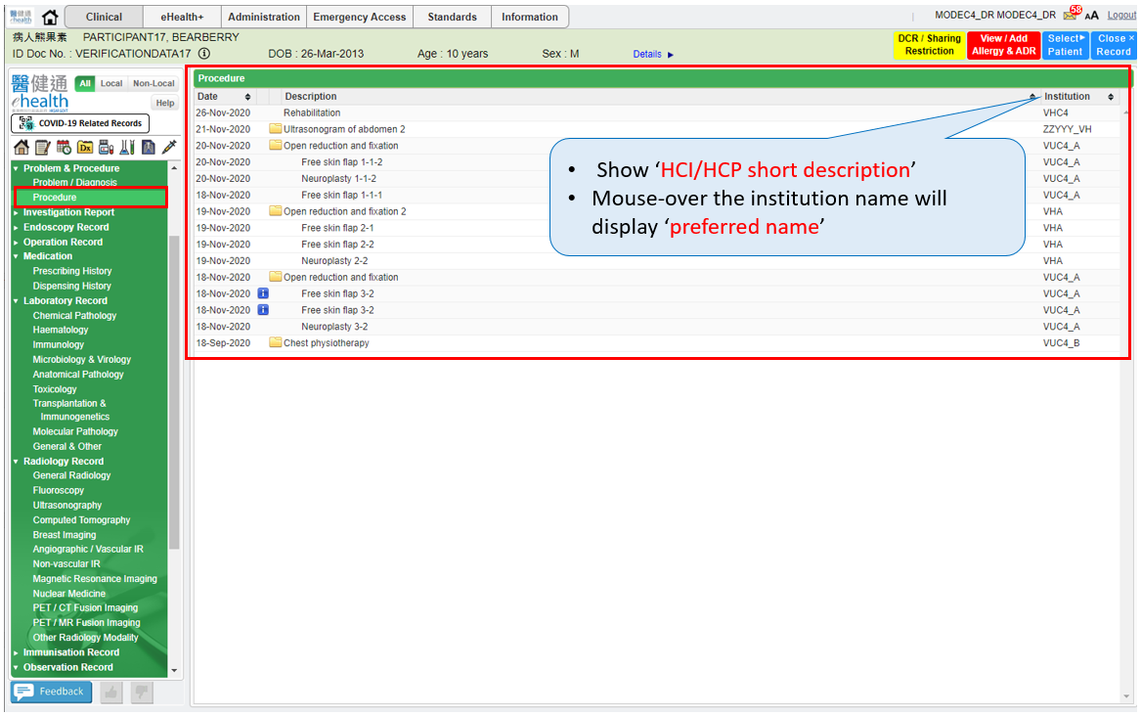
Notations:
It indicates the grouping of records with same recognized terminology ID.
Below Additional information will be provided after clicking it:
- Procedure comment available

- After clicking on the grouping of Procedure records to Detail View, it shows all Procedure records of selected terminology ID.
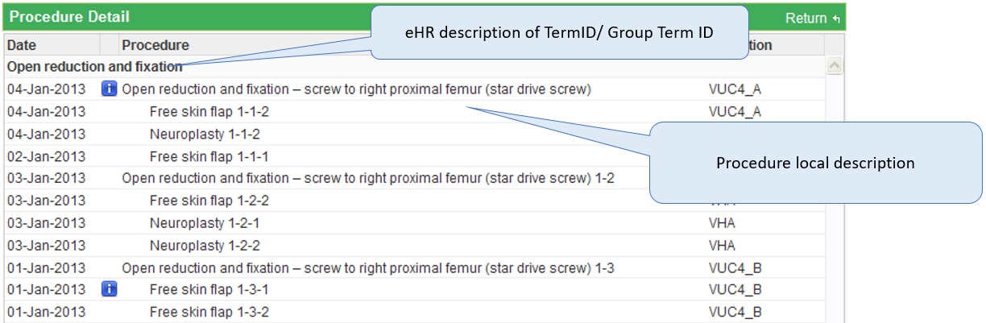

Appendix – Actual Data Values (Sample)

If the actual values entered are various from the test case, please provide actual values as below.
If the value is not inputted, please use [BLANK] to indicate that empty value is inputted intentionally.

